Men’s Apparel

Short Sleeve Polo $45. Long sleeve polo  $55

[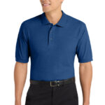](https://coppersclassic.com/wp-content/uploads/2025/09/424Wx635H-1225-Royal-0-K500RoyalModelFront5.jpg) [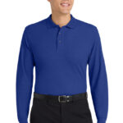](https://coppersclassic.com/wp-content/uploads/2025/09/424Wx635H-1557-Royal-0-K500LSRoyalModelFront2.jpg)

Men’s Hoodie. $55 Men’s Fleece vest. $55

 [](https://coppersclassic.com/wp-content/uploads/2025/09/1200W-4515-TrueRoyal-4-F219TrueRoyalModelSide2.jpg)